Name: __________________________________________________________________________ Hour: _____________
Algebra Chapter 4, Sections 1-2 Quiz REVIEW
Solve each system of equations by graphing:
1. y = 2/3x - 3  Y = -2x + 5  Solution: | 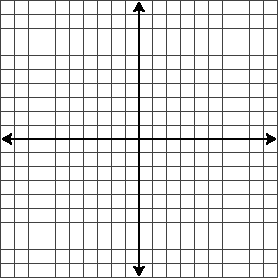
2. 4x + 2y = 2  4 – y = 3x  Solution: | 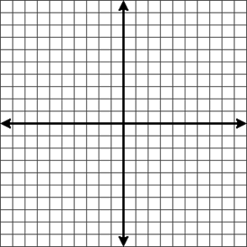
3. 6x + y = -2
3x + y = 1

Solution:

Solve each system of equations by substitution:
4. x – 5y = 1
-2x + 9y = -1

Solution:

5. x = 2y + 2
2x – 5y = 1

Solution:

6. -2x + y = -14
x = y + 8

Solution:

7. x + y = 27
y = x + 3

Solution:

