Name: ______________________________________________________________________ Hour: ________

**Chapter 1, Section 3 Practice**

Directions: *Solve each equation and check your work.*

1.  2. 

3.  4. 

5.  6. 

7.  8. 

9.  10. 

11.  12. 

13.  14. 

15. Jess spent minutes on the computer. Her sister spent  minutes on the computer, which was the same amount of time Jess spent. How many minutes was Jess on the computer?

16. Describe and correct the error in 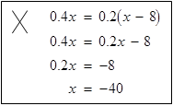solving the equation.