Name: ______________________________________________________________________________ Hour: ______
Chapter 2, Section 1 Practice Worksheet
Directions: Graph each equation by using a table of values
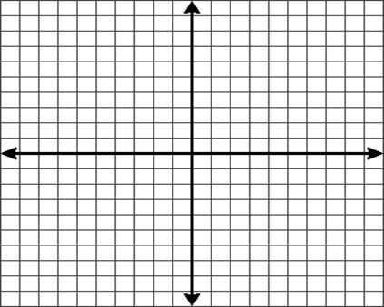
- y = -5x
X | Y = | Y | (X , Y)

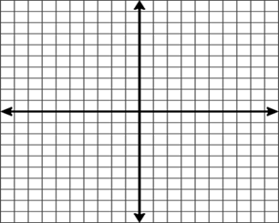
- y = ¼ x
X | Y = | Y | (X , Y)

- y = x – 3
X | Y = | Y | (X , Y)

- y = -7x – 1
X | Y = | Y | (X , Y)

- y = 3/4x – 1/2
X | Y = | Y | (X , Y)

- y = 5
X | Y = | Y | (X , Y)

- x = -6
X | Y = | Y | (X , Y)

- y = -3x – 4
X | Y = | Y | (X , Y)

- y = -2
X | Y = | Y | (X , Y)

- y = 1/4x + 3
X | Y = | Y | (X , Y)

