Name: _______________________________________________________________________________ Hour: _______

**Chapter 2, Section 2 Practice Worksheet**

Directions: Find the slope of each line indicated

1. 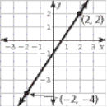 2. 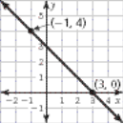 3. 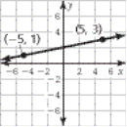

4. 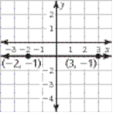 5. 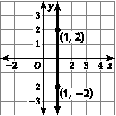 6. 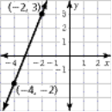

7. Through the points  8. Through the points 

9. Through the points  10. Through the points 

11. Through the points (-2, 3), (4, -8) 12. Through the points (6, 0), (-12, 4)

13. 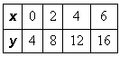 14. 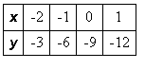 15. 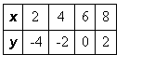

16. A ramp used to remove furniture from a moving truck has a slope of  The height of the ramp is 4 feet. How far does the base of the ramp extend from the end of the truck? Hint: draw the picture first!

17. An awning covers a window that is 4 feet high. When the awning is opened, it extends 2 feet from the base of the window. Find the slope of the awning. Hint: draw the picture first!

18. The back of a moving truck is 4 feet above the ground. A ramp extending from the back of the truck meets the ground 10 feet from the truck. What is the slope of the ramp?

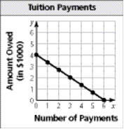19. Carla plotted the points on the graph below. In at least 3-4 complete sentences, explain what the slope of the line is and what the slope means in terms of the information displayed in the graph.