Name: _______________________________________________________________________________ Hour: _______
Chapter 2, Section 3 Practice #1
Directions: Identify the slope and y-intercept from each equation. Then, graph the equation.
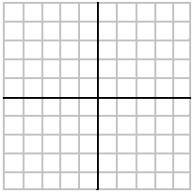
1. $y=2x+1$ 2.$y=3x-4$

m: m:

b: b:

3. $y=-2x+4$ 4. $y=-4x+3$

m: m:

b: b:

5. $y=\frac{3}{2}x-2$ 6.$y=\frac{1}{4}x+1$

m: m:

b: b:

7. $y=-2x-1$ 8.$y=4x$

m: m:

b: b:

9. $y=\frac{1}{2}x-4$ 10. $y=\frac{4}{5}x-5$

m: m:

b: b:

11. $y=\frac{-3}{4}x+3$ 12.$y=\frac{-1}{4}x$

m: m:

b: b:

