Name: \_\_\_\_\_\_\_\_\_\_\_\_\_\_\_\_\_\_\_\_\_\_\_\_\_\_\_\_\_\_\_\_\_\_\_\_\_\_\_\_\_\_\_\_\_\_\_\_\_\_\_\_\_\_\_\_\_\_\_\_\_\_\_\_\_\_ Hour: \_\_\_\_\_\_\_\_\_

**Algebra 1**

**Chapter 2, Sections 1-4 Quiz Review**

**Graph the following linear equations (use any method you prefer):**

1. **y = 1/4x - 2** 2) **y = -2x – 5** 3) **y = x/2 - 3**

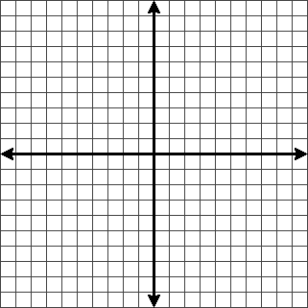

4) **y = 4** 5) **x = -7**

 

**Find the slope of each line:**

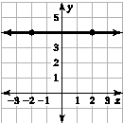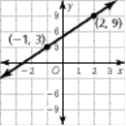TA: R:\msfl8wb01.01\Gr 8 Production\Gr 8 CRB\Gr 8_CR_Chap_02\Gr 8_CR_Chap_02_Art\msfl8_crb_pt_02_003.eps,2/4/2009 9:31:04 AMTA: R:\msfl8wb01.01\Gr 8 Production\Gr 8 CRB\Gr 8_CR_Chap_02\Gr 8_CR_Chap_02_Art\msfl8_crb_pt_02_002.eps,2/4/2009 9:30:41 AMTA: R:\msfl8wb01.01\Gr 8 Production\Gr 8 CRB\Gr 8_CR_Chap_02\Gr 8_CR_Chap_02_Art\msfl8_crb_pt_02_002.eps,2/4/2009 9:30:41 AM6) 7) 8) 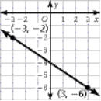

Find the slope of each line:

9)  10)  11) 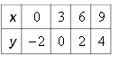

12) What is the slope of a line that is parallel to the line in #6? \_\_\_\_\_\_\_\_\_\_\_\_\_\_\_\_\_\_\_

13) What is the slope of a line that is perpendicular to the line in #8? \_\_\_\_\_\_\_\_\_\_\_\_\_\_\_\_\_

For problems #14-16:

* **Identify the slope**
* **Identify the x and y intercepts**
* **Graph the equation**

14) Equation: **y = 3x - 1** 15) Equation: **6x – 2y = 12**

Slope = \_\_\_\_\_\_\_\_\_\_ Slope = \_\_\_\_\_\_\_\_\_\_\_\_

X-intercept = \_\_\_\_\_\_\_\_\_\_\_\_ X-intercept = \_\_\_\_\_\_\_\_\_\_\_\_

Y-intercept = \_\_\_\_\_\_\_\_\_\_\_\_ Y-intercept = \_\_\_\_\_\_\_\_\_\_\_\_

 

16) Equation: **-18x + 9y = 72**

Slope = \_\_\_\_\_\_\_\_\_\_

 X-intercept = \_\_\_\_\_\_\_\_\_\_\_

Y-intercept = \_\_\_\_\_\_\_\_\_\_\_\_