Name: __________________________________________________ Date: ______________
Chapter 2, Section 1 Notes
Graphing Linear Equations
Today’s Learning Goal: At the end of today’s lesson, you should be able to graph a linear equation using a table of values and graph horizontal and vertical lines.

A linear equation is _______________________________________________________________
_____________________________________________________________________________. The points on the line are the ______________ of the equation.
Graphing a Linear Equation:
Step 1: Make a table of values.
Step 2: Plot the ordered pairs from the table of values.
Step 3: Draw a line through the points.
Example: Graph y = -2x + 1
X | Y = -2X + 1 | Y | (X , Y)

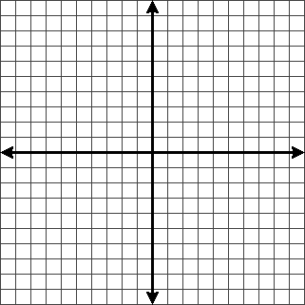

You Try: Graph y = -1/2 x + 2
X | Y = -1/2x + 2 | Y | (X , Y)

You Try: Graph y = 2x - 3
X | Y = 2x - 3 | Y | (X , Y)

Horizontal and Vertical Lines:
The graph of y = b is a ___________________________ __________________ passing through
(0, b).
The graph of x = a is a ___________________ ________________ passing through (a, 0).
More Examples:
Graph y = -3 Graph x = 2

Progress Monitoring: How do you feel about your level of understanding of graphing linear equations using a table of values? (Rate yourself from 0 (don’t understand at all) to 10 (doing awesome))
