Name: __________________________________________________________________ Date: _______
Chapter 2, Section 2 Notes
Finding the Slope of a Line
Today’s Learning Goal: At the end of today’s lesson, you should be able to find the slope of a line from a graph, from two coordinate points, or from a table.

Today, you will learn about slope and the various ways you can calculate the slope of a line. Recall that slope is
__________________________________________________________________________________
________________________. If a line has a positive slope, _____________________________________. If a line has a negative slope, ______________________________________________________________.
Part 1: Calculating Slope from a Graph:
To find the slope of a line when looking at a graph….
Step 1: Choose any two points on the line.
Step 2: Begin at one of the points.
Step 3: Count vertically until you are even with the second point. This is called the __________. If you travel down, the rise will be ___________. If you travel up, the rise will be ___________.
Step 4: Count over (horizontally) until you are at the second point. This is called the ____________. If you travel left, the run will be ____________. If you travel right, the run will be _____________.
Examples: Find the slope of each line.
A) 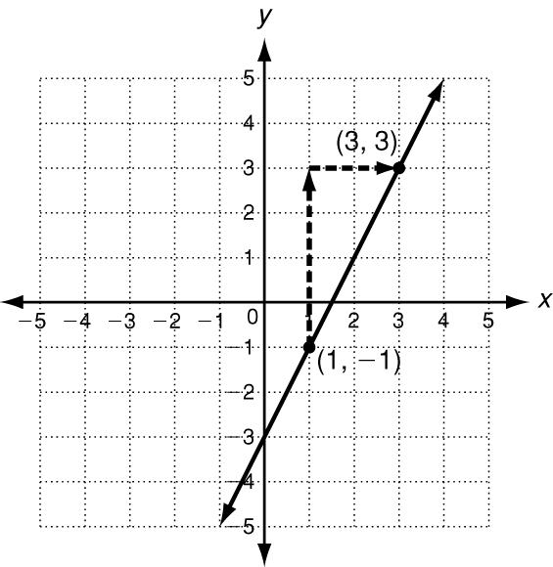 B) 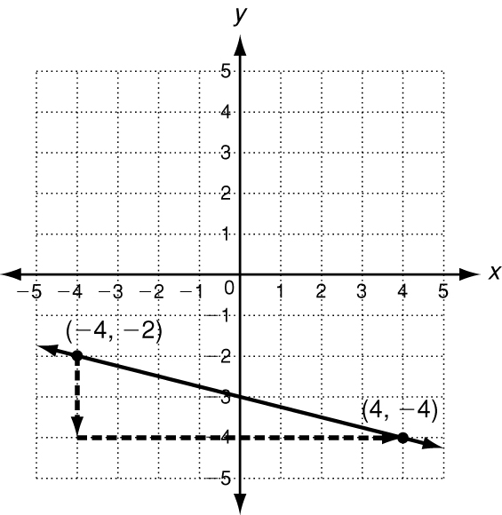 C) 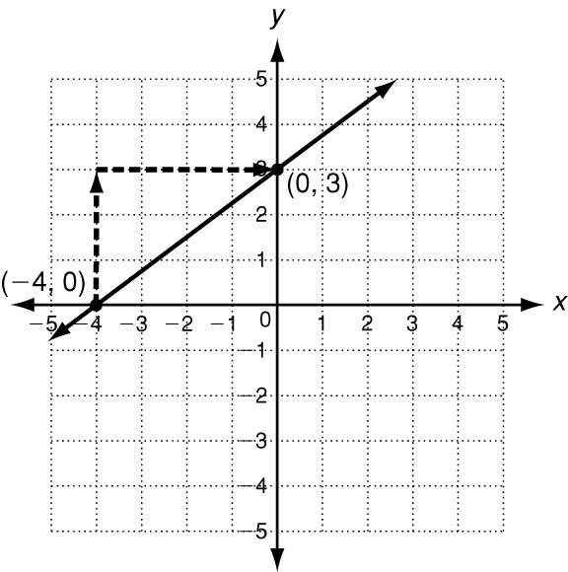

Part 2: Calculating Slope when given Two Coordinate Points:
The Slope Formula:
Examples: Find the slope of the line through the given points.
A) (6, 4) (-1, 3) B) (0. 4) (4, -2) C) (-1, -1) (-2, 5)

Part 3: Calculating Slope when given a Table:
How would you calculate the slope of the line from the table below?

Part 4: Horizontal and Vertical Slopes:
Horizontal and vertical lines have special slopes:
The slope of a horizontal line is _______________. The slope of a vertical line is _________________.
Example: Graph y = -4 Example: Graph x = 5

Part 5: Story Problems:
The slope of a ramp from the sidewalk to the street has to be The height of a ramp is 2.5 inches. What is the horizontal length (in inches) of the ramp?

Progress Monitoring: How do you feel about your level of understanding of finding slope of linear equations? (Rate yourself from 0 (don’t understand at all) to 10 (doing awesome))

