Name: __________________________________________________ Date: __________
Chapter 2, Section 6B Notes
Writing Equations of Parallel and Perpendicular Lines
Today’s Learning Goal: At the end of today’s lesson, you should be able to write an equation of a parallel or perpendicular line to a given line from a graph or equation.

Part 1: Writing an Equation of a Parallel line
Write an equation of the line that passes through the point (6, -2) and is parallel to the line
y = ½ x + 3.

Write an equation of the line that passes through the point (-2, 1) and is parallel to the line
y = 3x – 4.

Write an equation of the line that passes through the point (2, -3) and is parallel to the line
shown in the graph.
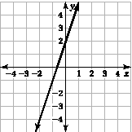

Part 2: Writing an Equation of a Perpendicular line
Write an equation of the line that passes through (-3, 1) and is perpendicular to the line shown in the graph.
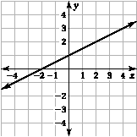

Write an equation of the line that passes through (4, 2) and is perpendicular to the line
y = -1/3x + 1.

Write an equation of the line that passes through (0, -1) and is perpendicular to the line
y = x – 6.

Progress Monitoring: How do you feel about your level of understanding of writing linear equations or parallel and perpendicular lines? (Rate yourself from 0 (don’t understand at all) to 10 (doing awesome))
