Name: ________________________________________________________________________________________________________ Hour: ___________
Algebra 1
Chapter 2, Sections 5-6 Quiz REVIEW
Part 1: Each problem below……
- Write the equation of the line with the given information in point-slope form
- Write the equation of the line in slope-intercept form
- Identify the slope and y-intercept of the equation
- Graph the equation

1. m = -1/3 (-3, -5)

Point-Slope form: Slope-Intercept form:

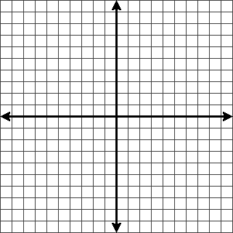
Slope = __________

Y-Intercept = ______________

2. (-2, 5) (6, 1)

Point-Slope form: Slope-Intercept form:

Slope = __________

Y-Intercept = ______________

3. (2, -7) (4, 7)

Point-Slope form: Slope-Intercept form:

Slope = __________

Y-Intercept = ______________

4. m = 0 (-3, 5)

Point-Slope form: Slope-Intercept form:

Slope = __________

Y-Intercept = ______________

Part 2: Answer each question below:
5. Write the equation of the line that passes through (-5, -2) and is parallel to the line y = 3/5x - 2.

6. Write the equation of the line that passes through (0, 4) and is perpendicular to the line y = -2/3x +1.

7. Write the equation of the line that passes through (-3, 1) and is parallel to the line y = 1/3x – 2.

8. Write the equation of the line that passes through (1, 4) and is perpendicular to the line y = 1/2x + 1.

Part 3: Complete each review problem (these problems come from sections 1-4):
9. Find the slope of the line through the points (-4, 6) (2, 2).

10. Find the slope of the line from the following table: 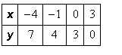

11. Identify the X and Y-intercepts: 12. Identify the X and Y-intercepts: 3x – 2y = 12
